School SEND Information Report
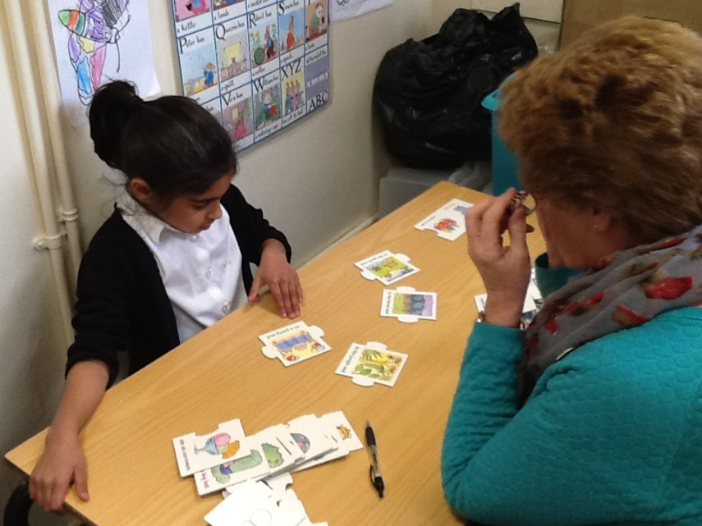

This report was compiled in collaboration with parents of SEN children with various levels of need.
If you would like any further information, please do not hesitate to contact the school.
The school SENCo is Liz McGrath. The governor with responsibility for SEN is Hannah Gillings. Both can be contacted through the school office using the contact details on the website. Werrington Primary School is a mainstream school. We make every effort to meet the needs of all pupils, including additional provision, as needed, for children with Special Educational Needs and Disabilities. We work with a range of outside agencies who support and advise staff and, in some cases deliver programmes in school.

Explanation of abbreviations and terms used in this report.
SEND – Special Educational Needs and Disabilities.
SENCo/ SENDCo – Special Educational Needs (and Disabilities) Co-ordinator.
EHCP – Education Health and Care Plan (A plan put together by the local authority with parents/carers and often the school to ensure a child’s needs are being met.)

- How does the school know if your child needs extra help?
- Werrington Primary School regularly assesses pupil’s academic progress through informal teacher assessments and more formal testing. Children who are not making expected progress are quickly identified and possible reasons for this are considered.
- School holds regular parent/carer consultations and parents and carers are encouraged to come into school to discuss any issues they feel their child is having, be they academic or social.
- The staff raise any concerns they may have about a child with the SENCo.
- We carry out individual assessments where there appears to be an issue. This is sometimes done by school staff skilled in this area and sometimes by outside agencies that the school buy in or refer to.

- How do I raise concerns if I need to?

- Talk to us – Please discuss any concerns with your child’s class teacher initially. If you wish to speak to the SENCo (Liz McGrath) please arrange an appointment in person, by phone or by e-mailing the school office. Staff will be pleased to discuss any concerns you may have and we value parent’s/ carer’s input when finding solutions to problems.

- How does school check that the support we give is effective?

- We monitor the progress of children on interventions regularly using class Provision Plans.
- We regularly review EHCPs and individual provision plans.
- We use Pre-Key Stage Standards to assess children working below the level expected for their Key Stage.
- We take advice from external agencies.

- How are the curriculum and learning environment adapted for pupils with SEND and what support/challenge does the school provide for children with SEND?

- Werrington Primary School are committed to helping all children to meet their potential and staff endeavour to make all reasonable adjustments to make this possible.
- Wherever possible we make adaptations to allow children to access Quality First Teaching.
- We use a range of resources including technology to allow children to demonstrate their learning.
- Every child has targets that identifies the next step for them. These are shared with parents regularly.
- School is a wheelchair friendly site, with ramps allowing easy access.
- Every effort is made to allow all children to access all activities provided. On some occasions additional adult support or resourcing may be needed to make this possible.
- We are fortunate to have some large classrooms which allow additional space for intervention groups.

- How does the school support children who need additional pastoral care and support families?

- If we feel your child would benefit from support for social, emotional or mental needs we will always discuss this with you first. If you have concerns about your child in this area, please let us know and we can discuss the best way to provide support.
- Not all children with these needs will be identified as having SEND, if needed, the support is available to all children in the school as needed including those identified as having SEND.
- We have a team of Learning Mentors who liaise with families and professionals and provide 1:1 and group support for children with social and emotional difficulties.

- Staff have participated in the following training.

- First Aid
- Paediatric First Aid
- Epipen and Asthma training
- Training for specific staff in use of hearing and radio aids.
- Training to support children with diabetes.
- Child Protection
- Growth Mindset (Helping all children to have a positive attitude towards learning.)
- In addition, staff frequently seek advice from various outside agencies and systems are in place to ensure that information is passed to adults working with relevant children.
- Irlens (Staff are not qualified to diagnose but can screen for possible difficulties.)
- Word Aware training
- Attention Autism
- Training in supporting children with vision impairment.
- Epilepsy training

- Which outside agencies may be involved?
School works with:
- Speech and Language Therapy
- Educational Psychology (this service provides a yearly planning meeting and may be commissioned by the local authority to assess an individual following an EHCP request)
- Sensory Support Service (For children with hearing and vision impairments)
- CAMHS (Child and Adolescent Mental Health Service)
- Support for Learning Team (Will assess children for possible learning difficulties including dyslexia, where it is felt that this could improve the teaching we offer the child.)
- Occupational Therapy
- School nurse
- Autism/ ADHD Advisory Service
- Pupil Referral Units for children with Social and Emotional Needs.
- EWT (Support for families of children with anxiety)
- Diabetic Nurses
- Younited – wellbeing triage service
- Hub schools who can support and advise.
- Young Carers
- A range of further services to support children and families accessed through an Early Help Assessment and the Multi Agency Support Group. There are a number of further services that we access less frequently, as the need arises. To access each of these services the school follows the relevant referral process. In every case, parent/ carer permission is obtained before a referral to one of these services is made.

- How does school obtain equipment and facilities to support children with SEND?

School has a range of facilities that particularly benefit children with SEND in school.
- We have a small sensory room, used for some interventions, a sensory garden area and a sensory path. We also have equipment for children who need sensory breaks.
- School keep a supply of various pencil grips, writing boards, weighted items, therabands, ear defenders, wobble cushions, chew and fiddle toys.
- Multisensory equipment for teaching curriculum subjects.
- If further equipment is felt to be particularly beneficial for a child or children school may purchase this, or some services will lend such equipment. It may also be possible to borrow equipment from other schools.

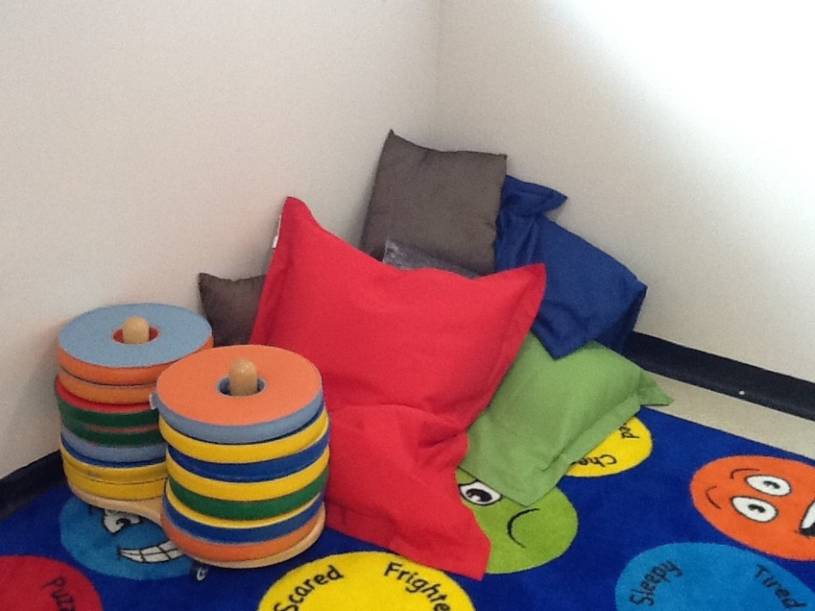
Sensory Room

- How do we consult parents/ carers of SEND children about the education of and provision for their child.

- Werrington Primary School strongly encourage all parents to meet regularly with their child’s teachers and any other key adults.
- Parents are informed of any additional support their child receives when this support begins, and at parent consultations.
- Staff welcome parental feedback on the effect of provision given.
- EHCPs are written and reviewed in consultation with the parents and parental wishes are prioritised.
- School work with parents, when support from outside of school is needed, to make referrals.

- How does the Werrington Primary consult children with SEND about their education?

- Children involved in additional interventions are encouraged to share their views regularly. Their comments are recorded on Intervention Forms.
- Children’s views are sought when producing and reviewing EHCPs and provision plans. Where it is very difficult to obtain these views, staff working closely with the child and parents/ carers help to interpret the child’s views.
- Staff take time to talk to children and respond to their needs and wishes sensitively.

- What should I do if I am not happy with the provision made for my child?

- Initially please talk to the SENCo (Liz McGrath) or the head teacher (Mrs R. Simmons) or the Deputy Head (Mr C. Moody) All can be contacted through the school office using the contact details on the website, or by coming to the school office.
- If you are still unhappy with the provision provided please speak to the school governors. The school office will be able to direct you to the appropriate governor.

- How does Werrington Primary involve other bodies, including health and social care in meeting the needs of children with SEND and supporting families where needed?

- Staff attend meetings and make referrals to health professionals.
- Where needed, additional agencies may be involved in providing targeted support to children.
- School staff complete EHAs (Early help Assessments) with families to allow them to receive support from a number of external agencies. They also organise and attend TAFs (Team around the Family meetings.) to monitor and continue support. If it is felt to be helpful (in agreement with parents) some cases may be heard at MASG (Multi Agency Support Group) which may be able to commission further services.

- Where can I find contact details for other agencies that provide support to children and families?

- Details, including contact details can be found on Peterborough City Council’s Local Offer.
- Alternatively, please come into school and staff will be happy to help you find this information.
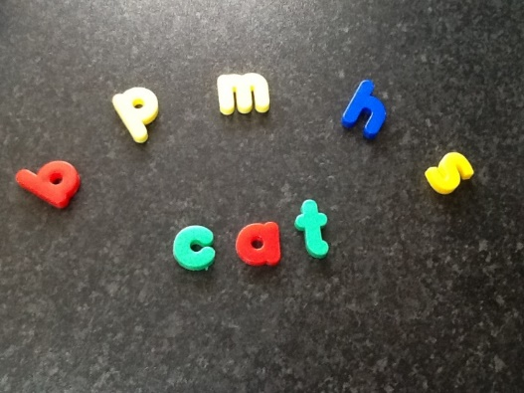
- How does the school make sure that SEND pupils make the best possible transitions into and out of Werrington Primary School?

- Staff liaise with local preschool settings. Where concerns are raised staff frequently visit the preschool setting, often to see the child or for a transition meeting. Paperwork is passed on and staff who will be working with the child are made aware of helpful information.
- Additional parent’s meetings commonly occur, where concerns are raised.
- On entry to Reception part time arrangements can often be considered, at the request of a parent, depending on the age of the child. Staff will advise on the impact of this according to the individual case.
- When children move on to secondary schools, relevant paperwork is passed on. Staff from the relevant secondary schools are invited to visit the children and the SENCo and Year 6 will ensure that they have spoken to key staff at the next school when there are particular concerns.
- In some cases, additional visits to the secondary school are arranged.
- Where a child moves school before the end of year 6 information is sent to the new school and the child’s teacher or SENCo will talk to staff at the child’s new school.
- Where relevant, school work closely with agencies such as the Autism Advisory service and ADHD Advisory service to support transitions.
The Local Authority publishes its Local Offer on its website
https://www.peterborough.gov.uk/residents/special-educational-needs/local-offer
or Google: Peterborough’s SEND Local Offer
This provides lots of helpful information for families of children with SEND.

