Werrington Primary

School

Behaviour Policy

Editions and Revisions

Policy Adopted | October 2011
Policy review | February 2014
Policy Adopted | May 2014
Leadership Team review Headteacher | May 2015
Reviewed | May 2017
Reviewed | September 2021
Addition of Physical Intervention details and Appendix 1 | February 2021
Further addition | September 2021
Revised | September 22
Revised | September 23

This policy should be read in conjunction with the WPS:
Equality Policy, SEN, Safeguarding and Child Protection Policies and Soke Education Trust Behaviour Statement.

At Werrington Primary School we want every member of the school community to feel valued, respected and aim to treat each person fairly and well. We are a caring community, whose ethos is built on trust and respect for all. The school’s Behaviour Policy is designed to support the way in which we can all learn and work together in a supportive way. We aim to make our school a safe, happy and stimulating learning environment.

Ethos, in relation to behaviour

A well-managed, well planned and engaging environment decreases potential for problems.

All teachers ensure that activities are well planned and resources well organised in order to ensure that every child knows what is expected of them and when. We need to teach behaviour as we teach other aspects of the curriculum. At Werrington Primary School we believe that well organised classes with carefully prepared lessons that take into account the range of abilities within the class tend to have fewer discipline problems. A calm controlled learning environment is conducive to positive learning as well as good behaviour. All children are treated sensitively to maintain their self-esteem.

Children are listened to and spoken to calmly. Every effort is made to diffuse potential problems before they arise through discussion, good organisation, consultation etc.

When disputes arise, all children involved are given a chance to explain their actions. They are encouraged to find a solution. No blame is given to one child more than the other until the facts have been determined.

School ensures that parents are involved in discussions as we recognise that parents often have an understanding of the route of behaviours, and working together is highly beneficial.

Positive Language

Staff try to phrase instructions to describe what they do want children to do, rather than what they do not, as we recognise that this is easier for children to process. For example: ‘Walk.’ rather than, ‘Don’t run.’
Saying ‘thank you’ after an instruction is also helpful as it implies that staff believe the child will comply. For example, ‘Walk. Thank you.’

How Positive Behaviour is Encouraged and Recognised

We believe that positive re-enforcement of good behaviour is more effective than negative punishments.

Positive behaviour management is likely to greatly reduce the need for reprimands and sanctions. Using this strategy shows all pupils that adults give more attention when behaviour is good.

Some children, for a variety of reasons, find this harder and will need more praise and rewards to maintain their good behaviour. Other children will be encouraged to understand this as those who find things difficult in any area will need more encouragement.

The school rewards good behaviour, as we believe that this will develop an ethos of kindness and co-operation. We praise and reward children in a variety of ways:
Rewards will not be taken, once given. Rewards may be given for effort in work, behaviour or attitude.

Please see the behaviour summary below for strategies used consistently across the school.

Rewards – these may be used throughout school but not necessarily in every year group.

-Verbal praise is given on most occasions when a reward is merited - some children will prefer to receive this discretely

-House points/ Dojo

-Responsibilities

-Stickers

-Stars of the week

-Written comments in books

-Letter of acknowledgement / note/ email home, conversation with parents or communication through reading diaries

-Accelerated reader golden ticket to choose a book

-Achievement jar for class reward (collect marbles or other objects for class reward.)

-Secret student

-Sending work to other adults

-Celebration assembly

-Positive notes/ emails sent home (or speak to parents.)

How Unacceptable Behaviour is Discouraged

To develop into adults with an understanding of the impact that their choices have on themselves and others, children must be taught that their behaviour has a consequence and sometimes speaking with the child about their actions will not be sufficient to help them understand this. In school we aim to teach pupils that a positive behaviour has a positive consequence (see above) and negative behaviour has a negative consequence.

Addressing unacceptable behaviour

All staff are expected to support the behaviour policy and challenge poor behaviour (as well as praise good behaviour) when they encounter it.

In most situations a conversation with an adult about the behaviour being unacceptable will be the most appropriate response to unwanted behaviour. This conversation should be held as soon as possible after the behaviour has occurred. It should be done calmly. If an adult does not feel able to do this calmly, for any reason, they should ask another member of staff for support.

These conversations are likely to explore what happened and investigate if there is more than one point of view. They are also likely to consider the impact of the child’s choice, including explaining the feelings of others impacted by the behaviour and agree a way forward considering whether the child feels able to change their behaviour or make amends or whether a further consequence is needed. (Restorative justice approach.) Prompt cards are available to use with children as a visual resource, during these discussions.

How staff address unacceptable behaviour

Staff will endeavour to stand at least two steps from the child they are reprimanding so that their behaviour is not construed as threatening. A firm tone will usually be used but ‘shouting’ is not beneficial. (There are times when staff may need to shout to alert a child of danger or prevent an aggressive or risky action from the child – this is likely to be a short instruction or calling of the child’s name – shouting for longer periods of time is not part of the school’s behaviour management policy.)

Staff will always endeavour to use deescalating body language, rather than escalating body language. This is likely to include giving a dysregulated child space.

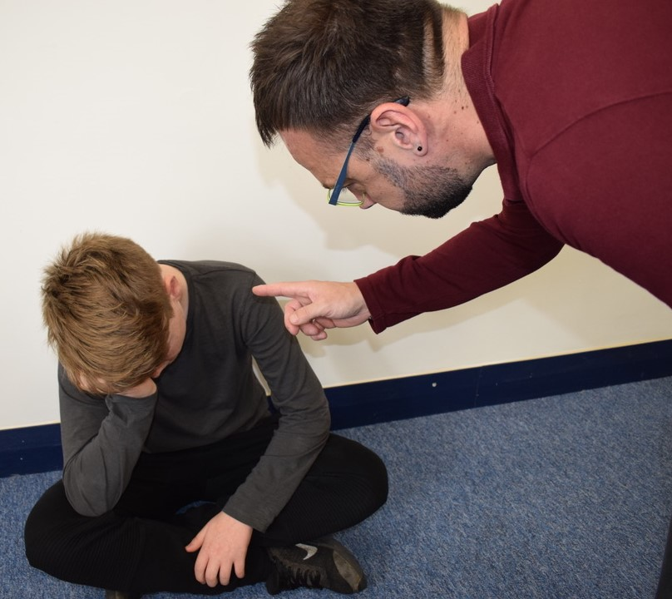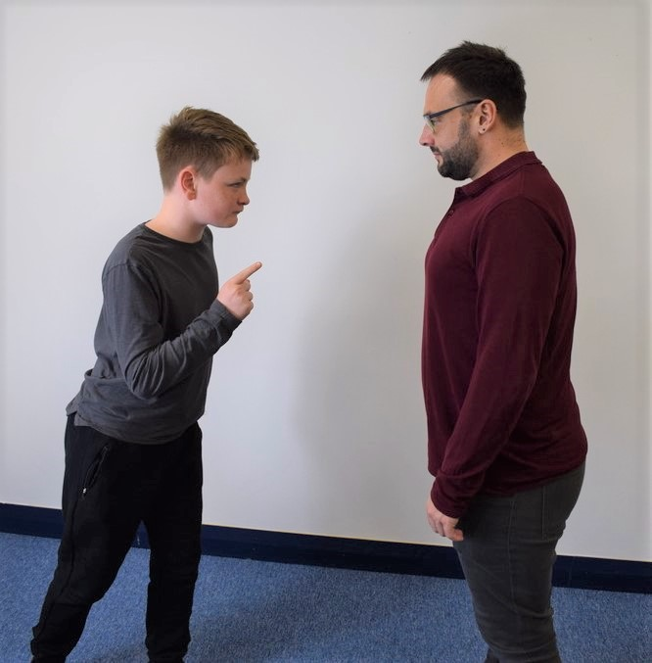
Example of escalating body language.
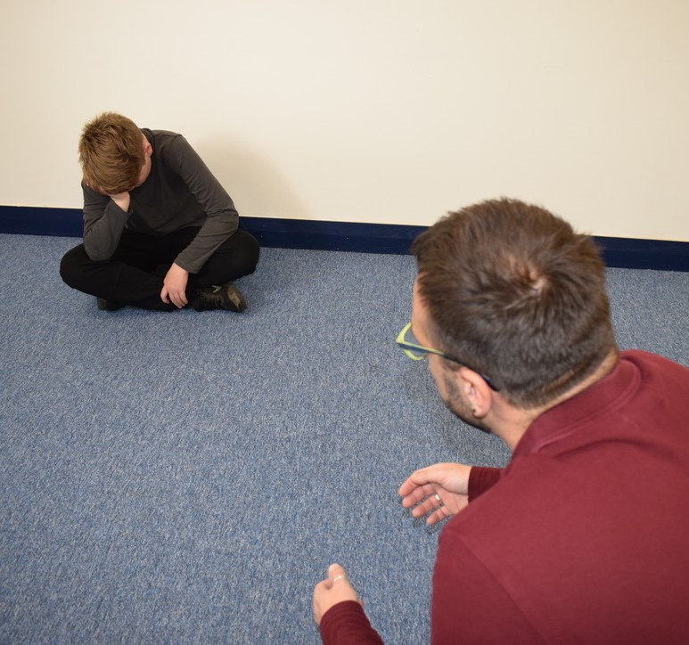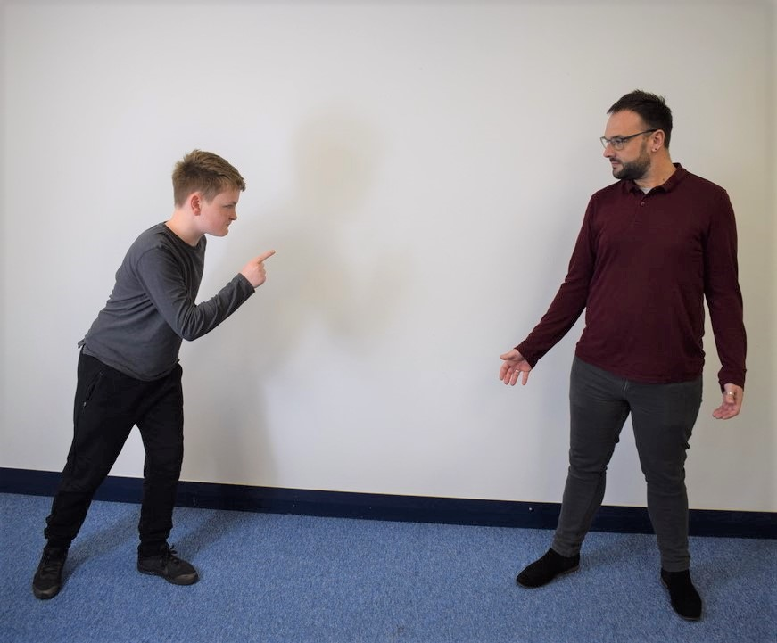
Examples of deescalating body language.

In some situations, there needs to be a consequence beyond explaining the impact of the actions. We believe that consequences are most powerful when they are logical. When this happens, it is easier for a child to understand that the consequence is a result of their behaviour. This means that there cannot be a set consequence for all instances of undesirable behaviour and staff will need to consider each situation as it arises to determine an appropriate consequence. Consequences are short term and may be used to protect others while the child is educated about changing their behaviour. Please see further information about consequences below.

De-escalation

If a child is extremely dysregulated it may be necessary to give that child time and space to calm down. Staff will make judgements about how to keep everyone safe while this occurs. This may include encouraging the child to leave the area or involving a different adult. In some cases, other children may need to be removed from the area to ensure their safety. This should be done calmly and staff will give reassurance to the children involved.

Sometimes, a child may be a slightly dysregulated or staff may know that this is likely to happen. A de-escalation script can be used in this situation. Please see the example below.

De-escalation script

Child’s name
I can see something has happened
I am here to help
Talk and I will listen
Come with me and …

This can be adapted. The key principals are, use the child’s name, repeat as needed, stay calm, don’t ask questions.

Consider giving limited choices eg. ‘Are you going to go to the sensory room with me or Miss Z?’

Other strategies that can be used to deescalate include:

-Appearing calm and using a modulated, low tone of voice
-Using simple, direct language.
-Avoiding being defensive, e.g. if comments or insults are directed at the staff member.
-Providing adequate personal space and not blocking a pupil’s escape route.
-Showing open, accepting body language, e.g. not standing with their arms crossed.
-Reassuring the pupil and creating an outcome goal.
-Identifying any points of agreement to build a rapport.
-Offering the pupil a face-saving route out of confrontation, e.g. that if they stop he behaviour, then the consequences will be lessened.
-Rephrasing requests made up of negative words with positive phrases, e.g. “if you don’t return to your seat, I won’t help you with your work” becomes “if you return to your seat, I can help you with your work”.

Logical consequences

Staff assess whether the consequence is logical by considering if it can be explained using the word ‘obviously’. (They do not always use
this word when explaining to children as this may not be appropriate for some pupils.)

For example:

‘You chose not to complete the work in the session so obviously you will need to complete it at break time.’

You hurt ….. at lunchtime so obviously you will need to stay with an adult at lunchtime tomorrow.

You stopped the others from learning when you were with ….. group so obviously you cannot work with them today.

‘You were unkind to ….. in class so obviously you will need to sit with the teacher today’ or the adult may say ‘spend some time at lunch time considering how this made her feel so you do not make this choice again’.

Other examples of consequences

Logical Consequences:

For children who are not making good choices
- Remove from current learning space to different area of classroom.
- Remove out of classroom to teaching partner or SLT.
- Missed minutes led by class teacher.
- Restorative conversation.
- Log behaviour in yellow book

Yellow Book:

- Inform parents if pupil is in yellow book.
- Logs monitored weekly by SLT and tracked.
- If child is consistently in the yellow book – involve SLT and start a behaviour contract.

In very serious cases
Very serious incidents are immediately referred to the headteacher or deputy head.

Exclusion and Suspension

The DFE 2017 Guidance on Exclusion will be followed.

The Headteacher has the responsibility of issuing fixed-term suspensions to individual children for serious acts of misbehaviour. For repeated or very serious acts of anti-social behaviour, the Headteacher may permanently exclude a child. These actions are taken only after the school governors have been notified. The Peterborough Local Authority and DFE guidance for exclusion/suspension will be followed.

School Rules

4Bs: Are you showing the 4Bs?
- Be Kind
- Be Respectful
- Be Responsible
- Be your Best

Lunchtimes
- Lunchtime supervisors and TAs will wear high visibility jackets so that the children can see them easily. They will stand in specific sites unless they need to deal with an issue. (These sites are described on the rota or see the lunchtime coordinator for further details.)
- Lunchtime supervisors will carry key fobs with restorative justice cards. These will not be used in every instance but will be used regularly in more complex situations.
- A key role of supervision staff is to prevent issues from occurring, in addition to dealing with them, when they have occurred. Supervisors will approach children who seem unhappy and speak with them.
- Notes about any behaviour incidents at lunchtime should be made on post its. Please include involved children’s names and classes. These should be handed directly to the class teacher at the end of lunch to put in the class yellow folders.
- More serious incidents (for example involving protected characteristics/ bullying/ significant harm or upset to someone) is likely to need further consequences and may need bringing to the teachers/ SLTs notice as soon as it happens.
- Play equipment will be available to each year group. Children will be encouraged to treat this equipment with respect and care.
- Each year group have sessions at lunch with PE coaches, supporting sports games and activities.
- In years 1 to 4, children will be given bands when coming in to the toilet or for a drink so adults can monitor the number of children indoors.
- Activities such as drawing/ music etc. are provided at various times for children at lunchtime.

At break and lunchtimes so that everyone stays safe we:

- Stay where we can be seen. (Make sure you can see a high visibility jacket and they can see you.)
- Keep our feet on the ground (when we are not on the trim trail.)
- Play gently – making sure no-one gets hurt.
- Sit when we are eating.
- Wear a band to go inside.
- Wear sensible clothes for the weather.
- Respect nature and the school environment.
- Use equipment respectfully.
- Only play football with the agreement of an adult.

Behaviour Involving Bullying or Protected Characteristics

Protected characteristics are:
- age
- gender or being LGBTQ
- being married or in a civil partnership
- being pregnant or on maternity leave
- disability
- race including colour, nationality, ethnic or national origin
- religion or belief

‘Bullying is behaviour that hurts someone else. It includes name calling, hitting, pushing, spreading rumours, threatening or undermining someone.
It can happen anywhere- at school, at home or online. It’s usually repeated over a long period of time and can hurt a child both physically and emotionally.’
NSPCC
‘Bullying is the repetitive, intentional hurting of one person or group by another person or group, where the relationship involves an imbalance of power. It can happen face to face or online.’
ANTI-BULLYING ALLIANCE

These incidents are taken seriously and reported to the senior leadership team. (On My Concern and often verbally too.) It may be necessary to explain to pupils that staff will need to discus and investigate what has happened and this may take time. While this is happening, the adults will separate the alleged victim/s and perpetrator/s. They will ensure that the victim/s are with other adults or in a place they feel safe.

Behaviour Contracts

All children are encouraged to take responsibility for their own behaviour – to a level that is appropriate to their understanding and ability. In some cases a behaviour contract may be drawn up, with an individual to help the student focus on what is expected of them. This will be done in consultation with relevant staff and parents.

Recording

Minor incidents are recorded in yellow books (class book) held by each class teacher. If there are a number ofminor incidents this will be discussed with parents. My Concern is used to record serious incidents or those with safeguarding implications. Class books and My Concern are monitored regularly by SLT to look for emerging patterns and appropriate action is then taken. For example, they may need to speak with a group, child or parent if there are frequent concerns or discuss an activity that is generating several logs (eg football at break) in assembly or increase supervision at that time.

The role of the Class Teacher

It is the role of each class teacher to ensure that school rules are followed in their classes and that pupils behave in a responsible manner.

Effective classroom management and stimulating lessons minimises poor behaviour and it is the responsibility of the class teacher to ensure that this is in place.

All class teachers at Werrington Primary School have high expectations of the children with regard to behaviour and they aim for all children to work to the best of their ability. Pupils are treated fairly with understanding by the class teacher and classroom codes are consistently enforced.

Efforts are made to build up an understanding of and relationship with the child. This makes discussion of attitudes and criticism of poor achievements or behaviour acceptable and can also provide an awareness of any underlying problems.

If a child misbehaves in class, the teacher deals with incidents, however, if the misbehaviour continues the teacher seeks help and guidance from other members of staff.

Parents/ Carers

The school works collaboratively with parents, so children receive consistent messages about how to behave at home and at school. School ensures that parents are involved in discussions as we recognise that parents often have an understanding of the route of behaviours, and working together is highly beneficial.

We aim to inform parents of any incidents that involves their child in a timely manner. Parents will be contacted promptly about any major incidents. Recurring minor incidents, recorded in yellow books will be shared with parents and action taken as necessary.

We expect parents to support their child’s learning, and to co-operate with the school, as set out in the Home/School agreement. We endeavour to build a dialogue between home and school and we inform parents promptly if we have any concerns about their child’s welfare or behaviour.
If the school has to use reasonable sanctions, parents should support the actions of the school. If parents have any concern about the way their child has been treated, they should initially contact the class teacher. Parents can contact class teachers by email (class teacher email addresses will be sent out to parents) or by phone via the office. If the concern remains, they should contact a member of the Senior Leadership Team, via the office. If the matter cannot be resolved, parents/carers should make contact with the school governors (contact details can be obtained from the school office). If these final discussions cannot resolve the problem a formal grievance or appeal process can be implemented.

Parents will be updated regularly of any decisions that could impact on their child’s learning or well-being; including the return of a perpetrator who has been absent.
Parents sign a home/school agreement when their children enter the school so that they are aware of the school’s expectations.

The Role of the Headteacher and Governing Bodies

The governing board has overall responsibility for:
- Ensuring that this policy, as written, does not discriminate on any grounds, including, but not limited to, age, disability, gender reassignment, gender identity, marriage and civil partnership, race, religion or belief, sex and sexual orientation.
- Promoting a whole-school culture where calm, dignity and structure encompass every space and activity.
- Handling complaints regarding this policy, as outlined in the school’s Complaints Procedures Policy.

The headteacher is responsible for:
- The monitoring and implementation of this policy and of the behaviour procedures at the school. This includes the policy’s effectiveness in addressing any SEMH-related drivers of poor behaviour.
- Establishing the standard of behaviour expected by pupils at the school.
- The day-to-day implementation of this policy.
- Publishing this policy and making it available to staff, parents and pupils.
- Reporting to the governing board on the implementation of this policy, including its effectiveness in addressing any SEMH-related issues that could be driving disruptive behaviour.

Use of Reasonable Force

Staff will only intervene physically when there is no other practical option and with regard to the guidance below.

Please also see the DfE guidance on use of reasonable force, July 2013. In addition to other details, this guidance states that:

• Reasonable force can be used to prevent pupils from hurting themselves or others, from damaging property, or from causing disorder.
• In a school, force is used for two main purposes – to control pupils or to restrain them.
• The decision on whether or not to physically intervene is down to the professional judgement of the staff member concerned and should always depend on the individual circumstances. 2 Section 93, Education and Inspections Act 2006 5

The following list is not exhaustive but provides some examples of situations where reasonable force can and cannot be used.

Schools can use reasonable force to:
• remove disruptive children from the classroom where they have refused to follow an instruction to do so;
• prevent a pupil behaving in a way that disrupts a school event or a school trip or visit;
• prevent a pupil leaving the classroom where allowing the pupil to leave would risk their safety or lead to behaviour that disrupts the behaviour of others;
• prevent a pupil from attacking a member of staff or another pupil, or to stop a fight in the playground; and
• restrain a pupil at risk of harming themselves through physical outbursts.

Schools cannot:
• use force as a punishment – it is always unlawful to use force as a punishment.

If an incident occurs where a member of staff needs to intervene physically that incident should always be logged and parents should be informed promptly. The incident should be recorded on the school form (Appendix 1) and placed as soon as is practically possible in the bound book in the office. Further instructions about how to log an incident of this type can be found in the bound books. Parents/ carers will be informed promptly.

Physical intervention of any sort will be kept to a minimum. If involved in a physical intervention the child will not also be being reprimanded verbally. If the child is doing something dangerous the member of staff may need to give an instruction, calmly and clearly, eg’ Put your feet down. Thank you.’ During a physical intervention it is not appropriate to reprimand a child. A restorative justice approach is likely to be used later, when the child is calm and the situation is safe.

It may be appropriate to guide children gently using hands on shoulders/ back/ caring cs.

Lifting down from furniture/ holding will only be used when necessary for safety reasons. If needed, this will always be logged in the bound red book in the office. Parents/carers will always be informed when this occurs.

Links to Other Policies

This policy links closely with the Policies for PSHE, Lunchtimes, and Equality Act.

Training and Development

All TA and teaching staff have had the opportunity to receive training on the changes to the behaviour policy in September 2022. Further training with specific groups of staff is given as needed and information is sent out to all staff about any changes or reviews to the policy.

Werrington Behaviour and Expectations Summary September 2023 – for staff

Set and teach these in the first 2 weeks of term and then embed and be consistent. To be reviewed at October half term.
We are creating posters for 4S Line and 4B’s to be displayed around school and in classroom.

Coming into the classroom:

KS1
- Silent
- Lined up
- Soft instrumental music playing (morning, after break and lunch)
KS2
- Silent
- Teacher greet at the door – positive start to each session
- Soft instrumental music playing (morning, after break and lunch)

Getting children’s attention:
Raise hand – say STOP, LOOK and LISTEN. Children respond by raising their hand. Teacher to say THANK YOU and children lower their hand.

Transitions:
1, 2, 3
Adult to use fingers (and voice where appropriate)
- 1 – Stand up, Stand Still and Silent
- 2 – Stand behind your chair
- 3 – Move – either silently or with a purposeful transition (e.g. counting in multiples)

4S Line: Are you in a 4S line?
- Silent
- Straight
- Smart
- Smiling
Rule - we walk everywhere in school.
Adults have presence when moving around school – modelling, praising and reminding.
At ALL times children should show 4S’s even when not in a line – e.g. going to the cloak room, coming in to the toilet. Please remind and expect this from everyone.

4Bs: Are you showing the 4Bs?
- Be Kind
- Be Respectful
- Be Responsible
- Be your Best

Google Doc of shared ideas of what each rule would look like. Teach these rules to your class.

Wet Playtime Activities:

Agreed list for KS1 and KS2 distributed.

Logical Consequences:

For children who are not making good choices
- Remove from current learning space to different area of classroom.
- Remove out of classroom to teaching partner or SLT.
- Missed minutes led by class teacher.
- Restorative conversation.
- Log behaviour in yellow book

Yellow Book:

- Inform parents if pupil is in yellow book.
- Logs monitored weekly by SLT and tracked.
- If child is consistently in the yellow book – involve SLT and start a behaviour
contract.

Talk Partners:

- Agreed phrase to use - TURN, TALK and TELL
- Use sentence stems
- Agreed Success Criteria as a staff
- Teach the children how to be a successful talk partner and plan in LOTS of opportunities to develop this skill in the first 2 weeks of term.

Break Times:

- High Viz worn by all adults on duty at playtime and lunch breaks
- Bands for children coming into the toilet at break and lunch.
- 4S Line

Appendix 1 To be filled in and stapled into the bound book in the office.

WPS RECORD OF PHYSICAL INTERVENTION
Date of incident: | Time of incident:
Pupil Name: | D.o.B:
Member(s) of staff involved:
Adult witnesses to intervention:
Pupil witnesses to intervention:
Outline of event leading to intervention:
Outline of incident of intervention (including method used):
Description of any injury sustained and any subsequent treatment:
Date /time parent/carer informed of incident:
By whom informed:
Outline of parent/carer response:
Signatures of staff completing report:
Brief description of any subsequent inquiry/complaint or action:

Appendix 2

Behaviour Contract
Section 1 – agreement
This contract is a written agreement between you and your teacher. The aim is to identify clear goals for you and support you in the classroom to improve your behaviour. Once this contract is in place, you should do everything you can to stick to your goals.

Pupil name: ________________________________ Date: ____________________
My goals
1

________________________________________________________

2

________________________________________________________

3

_________________________________________________________

To prevent my challenging behaviour, I can:

- ____________________________________________________

- ____________________________________________________

- ____________________________________________________

When I demonstrate challenging behaviour, you can help me by:

1. ._________________________________________________________________

2._________________________________________________________________

3.___________________________________________________________________
These are the consequences if I don’t meet my goals:

___________________________________________________________________________________________________________________________________________________________________________________________________________________________
These are the rewards if I meet my goals:
_________________________________________________________________________
_________________________________________________________________________
_________________________________________________________________________

My contract will be reviewed on: date
Pupil signature: ____________________________________
Teacher signature: __________________________________

Guidance about type of behaviour on yellow forms/ My Concern

