WPS Sustainability Projects – 2021/2022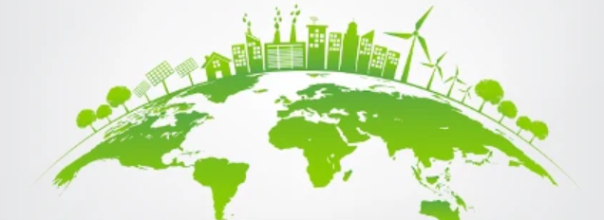

Year Group | Sustainability Theme – topic idea | Half Term
Reception | Plastic waste with our topic, 'Our wonderful world'. | Spring 1
Year 1 | Reducing Plastic Use linked to the story:  Clean Up! By Nathan Byron.  Exploring alternatives to plastic and the consequences for the planet of too much plastic use. | Spring 2
Year 2 | Beach defences to prevent erosion - linked to seaside topic | Summer 2
Year 3 | Deforestation – Linked to rain forests | Spring 1
Year 4 | Water pollution - linked to flushable waste - linked to Geography Hills, rivers and coasts topic. | Summer 2
Year 5 | Rising sea levels & melting of the ice caps - linked with Floodland | Summer 1
Year 6 | Local food production and food miles  School visit to Kingsdyke Nature Reserve and Wypemere Farm | Autumn 1

