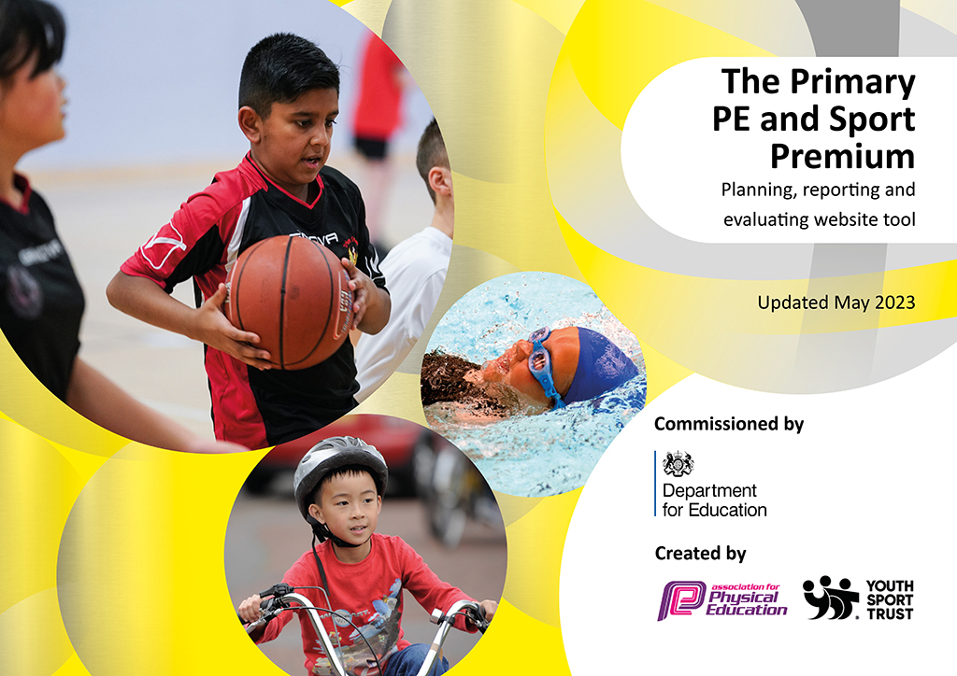
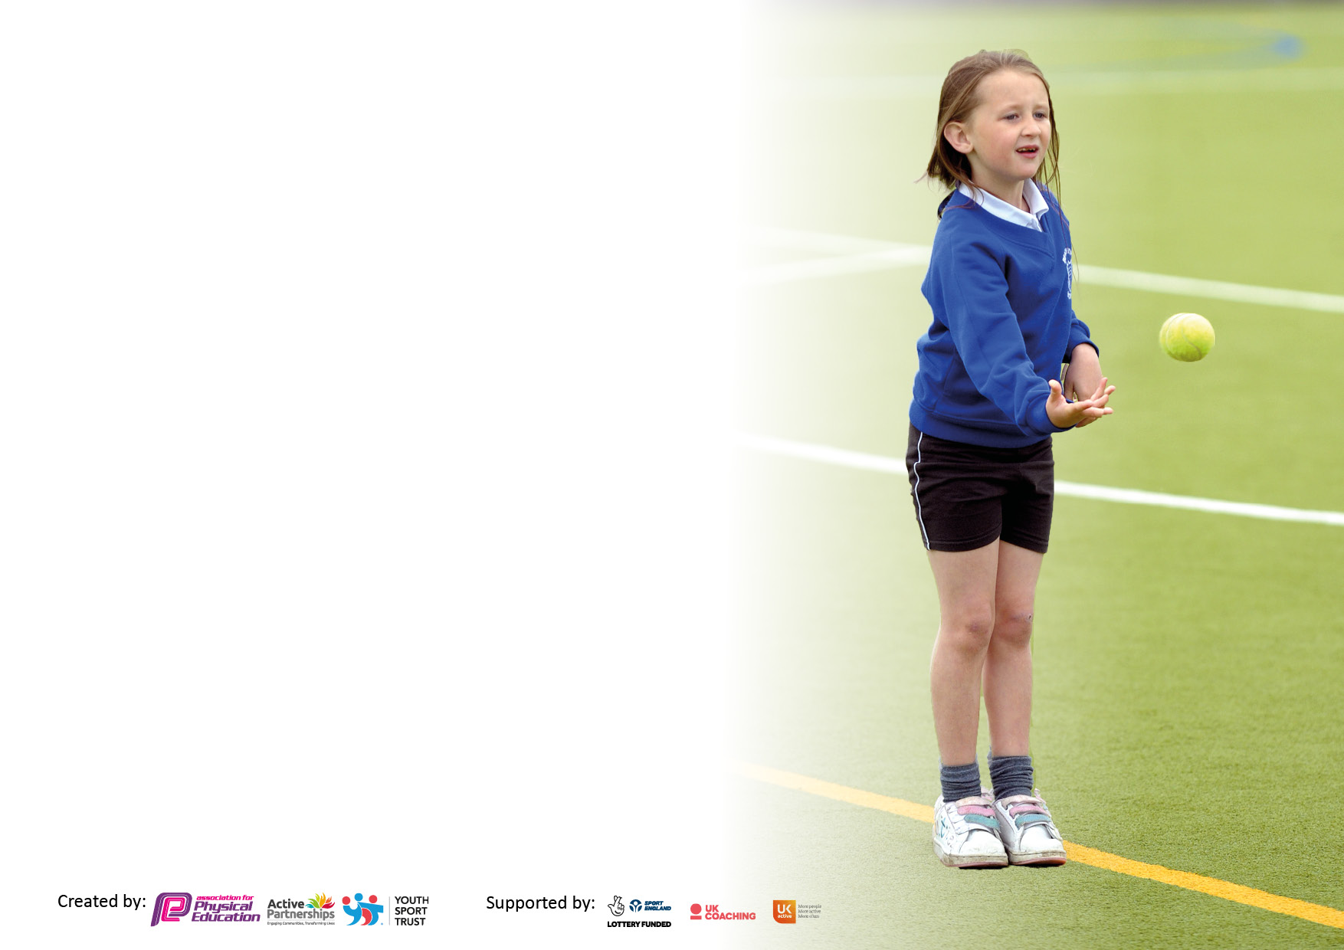

It is important that your grant is used effectively and based on school need. The Education Inspection Framework makes clear there will be a focus on ‘whether leaders and those responsible for governors all understand their respective roles and perform these in a way that enhances the effectiveness of the school’.

Under the Quality of Education Ofsted inspectors consider:
Intent - Curriculum design, coverage and appropriateness
Implementation - Curriculum delivery, Teaching (pedagogy) and Assessment
Impact - Attainment and progress

To assist schools with common transferable language this template has been developed to utilise the same three headings which should make your plans easily transferable between working documents.

Schools must use the funding to make additional and sustainable improvements to the quality of Physical Education, School Sport and Physical Activity (PESSPA) they offer. This means that you should use the Primary PE and sport premium to:

- Develop or add to the PESSPA activities that your school already offer
- Build capacity and capability within the school to ensure that improvements made now will benefit pupils joining the school in future years
- The Primary PE and sport premium should not be used to fund capital spend projects; the school’s budget should fund these.

Pleasevisitgov.ukfortherevisedDfEguidanceincludingthe5keyindicatorsacrosswhichschoolsshoulddemonstrate animprovement.Thisdocumentwillhelpyoutoreviewyourprovisionandtoreportyourspend.DfEencouragesschools to use this template as an effective way of meeting the reporting requirements of the Primary PE and Sport Premium.

We recommend you start by reflecting on the impact of current provision and reviewing the previous spend.

Schools are required to publish details of how they spend this funding, including any under-spend from 2021/2022, as well as on the impact it has on pupils’ PE and sport participation and attainment. All funding must be spent by 31st July 2023.

We recommend regularly updating the table and publishing it on your website throughout the year. This evidences your ongoing self-evaluation of how you are using the funding to secure maximum, sustainable impact. Final copy must be posted on your website by the end of the academic year and no later than the 31st July 2023. To see an example of how to complete the table please click HERE.

Details with regard to funding
Please complete the table below.

Total amount carried over from 2021/22 | £1,973
Total amount allocated for 2021/22 | £19,520
How much (if any) do you intend to carry over from this total fund into 2023/24? | £0.00
Total amount allocated for 2022/23 | £19,520
Total amount of funding for 2023/23. To be spent and reported on by 31st July 2023. | £ 21,493
Swimming Data
Please report on your Swimming Data below.

Meeting national curriculum requirements for swimming and water safety.

N.B. Complete this section to your best ability. For example you might have practised safe self-rescue techniques on dry land which you can then transfer to the pool when school swimming restarts.
Due to exceptional circumstances priority should be given to ensuring that pupils can perform safe self rescue even if they do not fully meet the first two requirements of the NC programme of study
What percentage of your current Year 6 cohort swim competently, confidently and proficiently over a distance of at least 25 metres?  N.B. Even though your pupils may swim in another year please report on their attainment on leaving primary school at the end of the summer term 2022.  Please see note above | 72%
What percentage of your current Year 6 cohort use a range of strokes effectively [for example, front crawl, backstroke and breaststroke]?  Please see note above | 72%
What percentage of your current Year 6 cohort perform safe self-rescue in different water-based situations? | 77%
Schools can choose to use the Primary PE and sport premium to provide additional provision for swimming but this must be for activity over and above the national curriculum requirements. Have you used it in this way? | No

Action Plan and Budget Tracking
Capture your intended annual spend against the 5 key indicators. Clarify the success criteria and evidence of impact that you intend to measure to evaluate for pupils today and for the future.

Academic Year: 2022/23 | Total fund allocated: £19,520 + £1973 | Date Updated: 17.07.2023
Key indicator 1: The engagement of all pupils in regular physical activity – Chief Medical Officers guidelines recommend that primary school pupils undertake at least 30 minutes of physical activity a day in school |  |  |  | Percentage of total allocation:
 |  |  |  | 18.2%
Intent | Implementation |  | Impact
Your school focus should be clear what you want the pupils to know and be able to do and about  what they need to learn and to  consolidate through practice: | Make sure your actions to achieve are linked to your intentions: | Funding allocated: | Evidence of impact: what do pupils now know and what can they now do? What has changed?: | Sustainability and suggested next steps:
To give the children the opportunity to be active at more times throughout the day. | Playtime and lunchtime play equipment has been purchased for each year group.  Sports coaching has been organised for lunchtime to provide the children the opportunity for extra coaching. | £673.99  £3250.00 | The children are visibly more active at playtime and lunchtime. One year 4 girl said, “I love the play equipment. It keeps me active during my lunchtime.” | To ensure that the children continue to be active throughout the day.  To ensure that the playtime and lunchtime equipment is kept well stocked. Audit has already taken place.
To ensure that all pupils take part in the active mile for 15 minutes each time. | The active mile is embedded in years 1-6. | Free | The children, who have been identified as the ‘least active’ now take part on the active mile as all children in these year groups take part.  Children are continuing to report that they feel more focused in lessons after they have done the active mile.  Children are also continuing to improve their active mile times.  A year 6 boy said, “I have improved my mile time by 2 minutes. I’m very proud of myself.” | The active mile is now embedded in Year groups 1-6.  This will be sustained in the future and will benefit children joining the school.
To ensure that all children take part in two hours of PE each week. | The PE timetable was updated, which allowed each class to fulfil their allocated PE time. | Free | Children are having two one-hour lessons a week, therefore children for active for two hours a week from just their PE lessons. | The PE curriculum and timetable will be reviewed before the next academic year.
To embed physical activity in the school day by promoting active travel to school. | Bike-ability was organised for year 6. | Free | In the summer term, many of the year 6 children biked to school. | Safe and active travel will continue to be promoted in school.
To embed physical activity in the school day by promoting active lessons. | Cross-curricular orienteering has mapped the school and installed new orienteering infrastructure. They have also installed the infrastructure for EYFS and KS1 children.  All teaching staff have received training on how to effectively use the cross-curricular orienteering course. | Cost of EYFS and KS1 infrastructure to be paid in the next academic year. | Outdoor adventurous activity lessons took place using the new infrastructure.  Children in some year groups took part in orienteering as part of other lessons, such as SPAG. | This will be sustained in the future and will benefit children joining the school.  Any new teaching staff that join the school will be shown the resources to create active lessons.
To increase the number of school sports clubs | Our new PE provider offers at least one sports club after school each day | Parents / carers pay for the sports clubs | The number of children who attend sports clubs has now significantly increased. | We will work with our PE provider to ensure that this will continue in the next academic year
Key indicator 2: The profile of PESSPA being raised across the school as a tool for whole school improvement |  |  |  | Percentage of total allocation:
 |  |  |  | 0%
Intent | Implementation |  | Impact
Your school focus should be clear what you want the pupils to know and be able to do and about  what they need to learn and to  consolidate through practice: | Make sure your actions to achieve are linked to your intentions: | Funding allocated: | Evidence of impact: what do pupils now know and what can they now do? What has changed?: | Sustainability and suggested next steps:
To raise the profile of sport by informing children of local clubs and sports team. | The PE coordinator has updated the sports board to show local sports clubs. | Free | Children are aware of the sports that take place in school.  Children are aware of the local clubs that they could attend.  Sporting participation and achievement is promoted on the sports board.  Some children have reported that they attend these clubs outside of school. | A number of children have reported that they have joined sports clubs this year.  The sports board will be updated in the next academic year.
To raise the profile of PE and sport by achieving the School Games Gold Mark. | The PE coordinator has planned what needs to be done in order to achieve the Gold Mark. | Free | The school has been recognised as achieving the School Games Gold Mark. This means that there has been a significant engagement in the School Games (including keeping young people active), against a national benchmark. This is the second year in a row that the school has achieved this award. | To maintain the School Games Gold Mark in future years.
To promote self-confidence, personal responsibility and improved attitudes to learning for some pupils in year 5 and 6 by investing in Pioneer Intervention (cadets). | The Head teacher and PE coordinator have met and have agreed how best to implement Pioneer Intervention. The Bronze award has been completed in the Summer term. The previous year’s cadets have completed the Silver and Gold award this year. | Cost is included above. | Some of the children, who take part in cadets, have said that they feel that they can now use the skills that they have learnt in cadets (such as responsibility) in their classrooms and wider lives.  One child who attends cadets said, “I feel like my resilience has improved since going to cadets. I aim to implement this in the classroom and my life outside of school.” | The children have already committed to the Silver and Gold awards. These will take place in the next academic year.

Key indicator 3: Increased confidence, knowledge and skills of all staff in teaching PE and sport |  |  |  | Percentage of total allocation:
 |  |  |  | 26.2%
Intent | Implementation |  | Impact
Your school focus should be clear | Make sure your actions to | Funding | Evidence of impact: what do | Sustainability and suggested
what you want the pupils to know | achieve are linked to your | allocated: | pupils now know and what | next steps:
and be able to do and about | intentions: |  | can they now do? What has
what they need to learn and to |  |  | changed?:
consolidate through practice:
To ensure all teaching staff are confident and have the required knowledge to teach PE and sport to a high standard. | Liaised with Total Sports to organise CPD for each year group (1-6) 3 times a year. | £5625.00 | All teachers who have had CPD have reported an increase in confidence, knowledge and skills.  Teachers reported that their confidence in dance, fitness, gymnastics and hockey has increased.  A learning walk of PE lessons has shown that PE is being taught to a high standard across the school. | New members of staff to receive CPD when they join the school, either by PE Coordinator or by Total Sports  CPD sessions will be continue to happen three times a year for each year group (1-6).
Key indicator 4: Broader experience of a range of sports and activities offered to all pupils |  |  |  | Percentage of total allocation:
 |  |  |  | 46.4%
Intent | Implementation |  | Impact
Your school focus should be clear | Make sure your actions to | Funding | Evidence of impact: what do | Sustainability and suggested
what you want the pupils to know | achieve are linked to your | allocated: | pupils now know and what | next steps:
and be able to do and about | intentions: |  | can they now do? What has
what they need to learn and to |  |  | changed?:
consolidate through practice:
To offer children in year groups 1-6 the opportunity to participate in sports, as part of the Service Level Agreement (SLA) with Arthur Mellows Village College (AMVC). | The PE coordinator has attended regular SOKE Cluster meetings to understand expectations and receive dates of upcoming events.  The PE coordinator has also liaised with each year group to organise transport and letters to these events. | £4000.00 | The following events were organised:  Year 1: multi-skills  Year 2: multi-skills  Year 3: dance/gymnastics festival  Year 4: athletics  Year 5: table tennis  Year 6: basketball  The pupils who attended these events have learnt knowledge and skills that supports the learning that they have undertaken at school. | We have committed to the SLA for the next academic year.
To offer team building activities to children in year groups 3-5. | The PE coordinator has organised team building to happen for children in these year groups. | £2400.00 | 27% of children reported that they hadn’t taken part in team building activities before. | We aim to run team building activities for the same year groups in the next academic year.
To allow children in all year groups to experience using climbing and balancing apparatus | The PE coordinator has worked with the Site Office and Headteacher to organise climbing and balancing apparatus. | £3562.00 | The impact of the new climbing and balancing apparatus will be seen in the next academic year. | This new equipment will be used by children who attend Werrington Primary school for years to come.

Key indicator 5: Increased participation in competitive sport |  |  |  | Percentage of total allocation:
 |  |  |  | 9.2%
Intent | Implementation |  | Impact
Your school focus should be clear | Make sure your actions to | Funding | Evidence of impact: what do | Sustainability and suggested
what you want the pupils to know | achieve are linked to your | allocated: | pupils now know and what | next steps:
and be able to do and about | intentions: |  | can they now do? What has
what they need to learn and to |  |  | changed?:
consolidate through practice:
To increase the number of school competitions that all children take part in. | Competitions have been organised by the staff at AMVC as part of the SLA.  The PE coordinator has organised letters and transport for these events.  We have organised team-building activities, which have allowed children in years 2-6 to work together and compete against each other within their classes. | £1985.00 | Please note that due to Covid-19, all of the events were planned but we were not able to attend all of them.  - EYFS and KS1 school sports day  - Year 3 and 4 sports day  - Year 5 and 6 sports day  - Year 5 and 6 SOKE football competition  - Year 5 and 6 netball  - Years 3, 4, 5 and 6 SOKE cross country competition  - Years 3, 4, 5 and 6 Peterborough schools’ cross country finals  - Year 4 whole year group athletics event and competition  - Year 5 whole year group tag rugby event and competition  - Year 6 whole year group basketball event and competition  - Years 3, 4, 5 and 6 SOKE athletics competition  - Competitive elements of PE lessons | We have committed to attending sports competitions in the next academic year.

Signed off by
Subject Leader: | 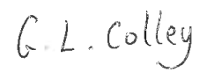
Date: | 05.07.2023

