Werrington Primary
School

Phonics Policy

Jo Simpson | September 2019
Jo Simpson | November 2023

At Werrington Primary School we strive to ensure that all children become successful, fluent readers by the end of Key Stage One and believe this is achievable through a combination of strong, high quality, discrete phonics teaching combined with a whole language approach that promotes a ‘Reading for Pleasure’ culture. This policy is aimed at reinforcing a consistent, high quality approach to the teaching of phonics across the Early Years Foundation Stage, (EYFS,) Key Stage One and on into Key Stage Two for children who still need this further support.

Intent: • To teach children aural discrimination, phonemic awareness and rhyme to aid reading, writing and spelling development
. • To encourage the use of segmenting and blending so that decoding skills provide a sound foundation for reading, writing and spelling.
• To ensure the teaching of phonics is lively, interactive and investigative.
• To enable children to use phonic awareness across the curriculum.
• To ensure that children know the 44 phonemes within the English language.
• To teach children to recognise the graphemes within words and associate them with the appropriate phoneme when reading.
• To provide children with strategies to identify and decode ‘tricky words.’

Objectives
• To provide consistent, high quality phonics teaching that ensures all children have a strong foundation upon which to tackle the complex processes of reading and writing.
• To ensure that the teaching of synthetic phonics is systematic and progressive throughout the foundation stage, key stage one and key stage two for those children needing interventions to support phonetic knowledge and understanding.
• To ensure that children have sound phonetic knowledge, understanding and skills so that they can decode words confidently and engage with higher order reading and writing skills.

Implementation:
Curriculum, Teaching and Learning Guidance
At Werrington Primary School, we follow the DFE validated scheme Supersonic Phonic Friends.
All Year One children take the ‘Phonics Screening Check’ - a statutory assessment required by legislation. Those who do not meet the pass mark will be given support and intervention programmes in Year Two, eg. revision of previously learnt phases focusing on gaps in knowledge as well as practice of reading real & non words, to provide them with sufficient knowledge and understanding to re-take the ‘Phonics Screening Check’ and obtain a pass mark. Those children who do not obtain the required level set by the ‘Phonics Screening Check’ will receive phonics teaching through phonic intervention groups provided by teachers and TA’s and any other additional phonics and/or spelling intervention programme.
Planning for phonics will be done separately from literacy but with the understanding that good phonics teaching should link to the literacy needs of the children within a literacy lesson and across the curriculum.
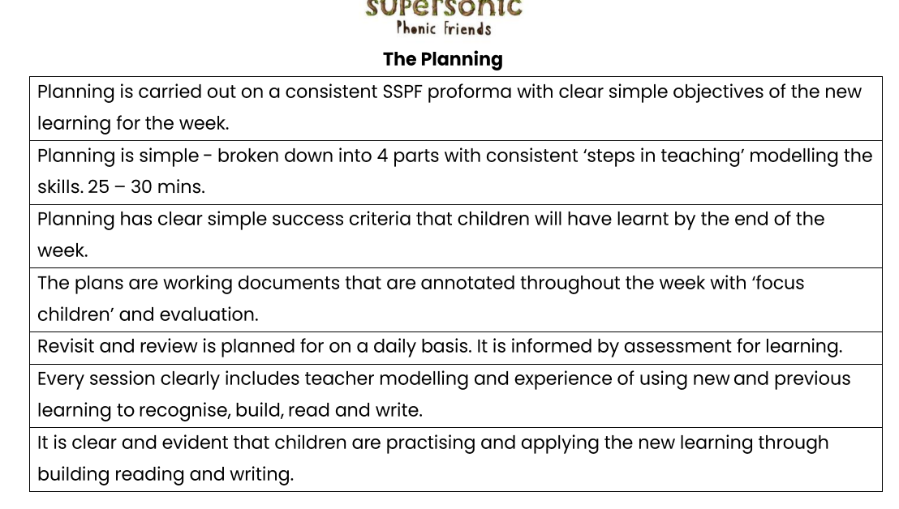
Teachers use assessment to inform effective provision for all children, using this to plan and deliver well differentiated lessons that engage and challenge all children within the lesson. This assessment should inform the rate at which children progress through the phases and secure a sound understanding of phonics.

As children enter Reception from various preschool settings, Phase 1 (Firm foundations) continues in the first weeks of the Autumn Term in Reception. Basic 2 sounds will be introduced and then consolidated in play based, child initiated activities. Children in Reception will be taught a discrete phonics session daily as a whole class focusing on reading and writing. Phonics skills are also embedded in writing and reading tasks in English sessions. Groups will be differentiated to ensure that all children are reaching their full potential within a challenging and supportive environment. The driving ethos should be for all children to be working within Basics 4 by the end of Reception and have a sound understanding in order to start Chooses to Use phase by the start of Autumn Term 2 in Year 1. Children are introduced to the “tricky words” and aim to read and write the high frequency words Basics 2 to 4 before they enter Year 1.
Children in Year 1 have access to high quality daily phonics sessions. The underlying aim of Year 1 should be to ensure all children have completed Basics 4, Chooses to Use and Switch it Mitch and be ready to begin Year 2 Supersonic Phonics Spelling rules, upon entry into Year 2. They should have plenty of practise in recognising ‘Alien’ or pseudo words, in readiness for the Phonic Screening Check and to give them the confidence to read any word. Children learn to read and spell the Year 1 Common Exception Words
Children in Year 2 will have access to high quality SPAG Provision (Supersonic Spelling Rules). The underlying aim in Year 2 is to ensure that all children have successfully completed the phonics programme while revisiting earlier phases to reinforce previous learning and to also re-experience common exception words that they have encountered before.
Children in Year 3 who have not reached a sufficiently proficient level in GPC awareness and application will have intervention programmes arranged to provide for this need. Children in Key Stage 2 who have not attained a sufficient skill level in GPC awareness and application will have provision in small intervention groups in regards to phonics and/or spelling across the key stage.

Classroom Environment
In each class is an age appropriate Phonics display, concentrating on both sounds and key words. Each class displays the characters from Supersonic Phonic Scheme to support the phonic skills the children are learning. In Reception phonic activities are always available as part of child initiated learning.

Parental Involvement
Parental involvement is key in the acquisition of Phonics. All children in Reception, Year 1 and 2 are expected to read 4 x a week and from Autumn 2 as in line with the whole school
A Phonics Workshop for Reception parents is held in the Autumn term and a Phonics Workshops for Year 1 parents and Year 2 parents whose children need to re-sit the phonic screening during the spring term.
Impact:
Assessment
In the EYFS and KS1 we assess pupil progress on our SSPF Phonics assessments at each each phase. Year 1 teachers and Children in Year 2 who need to retake carry out Phonics Screening Check, practise papers each half term to identify specific skills or any gaps in learning and then create target groups for additional phonic sessions to address these gaps.

